Task1 output :

InvalidNameException :

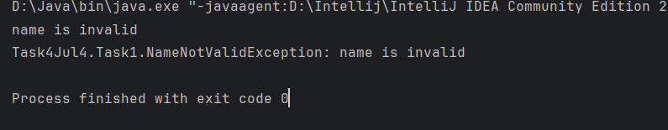

InvalidAgeException :

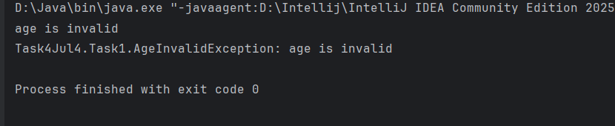

TasK2 output :

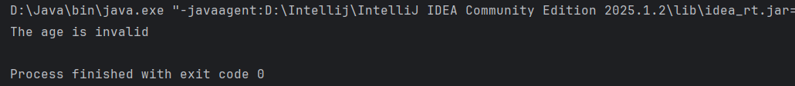

Task3 output :

When we enter the number within the range :

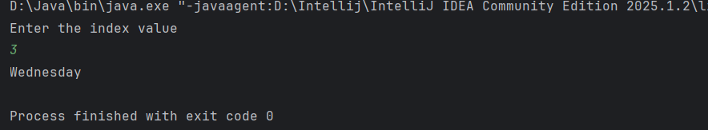

When we enter the number out of the range :

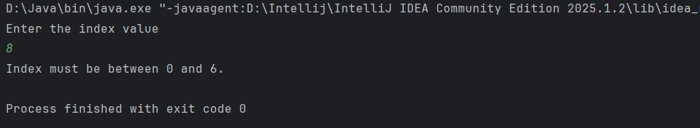

Task4 :

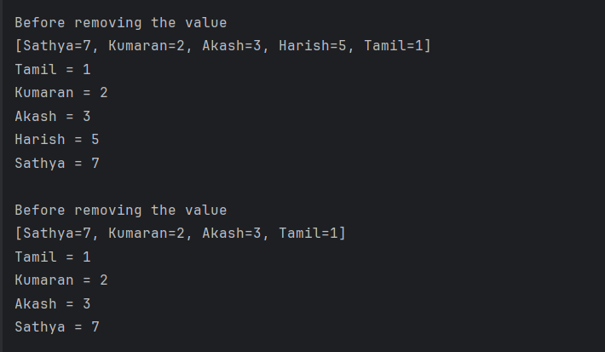

Task5 :

